WC 6/2/23 - Reception Maths Homework
This week we would like you to talk to your child about time. We have provided some practical activities for you to complete with your child over the half term.
In addition to this, when talking to your child try use any of the following vocabulary:
- Before, after, next
- Day & night
- Minutes, seconds, hours
- Days of the week
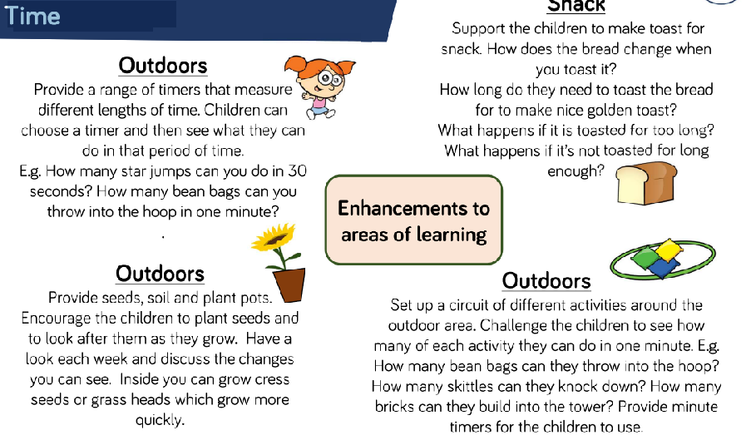
Our topic next term is going to be called Feed me please! The topic will include learning about:
Food and plants
Spring
Easter
Human and plant changes
Gardening
Weather
Measuring time (days, months)

We would like to brighten up our outdoor area by planting, flowers growing seeds and vegetables. If you have any spare plant pots, soil, old wellingtons, seeds, watering cans, spades, garden decorations etc to help us along the way, this would be much appreciated.
In the meantime, we hope you all have a relaxing and happy half term and thank you for your continuing support.
The Reception Team

