Reception Maths Homework.
This week we have been solving some tricky maths problems. Therefore, homework this week is a roundup of all our learning from the year. There are a number of activities that you could share with your child. Please work through these over the next few weeks and into the summer.

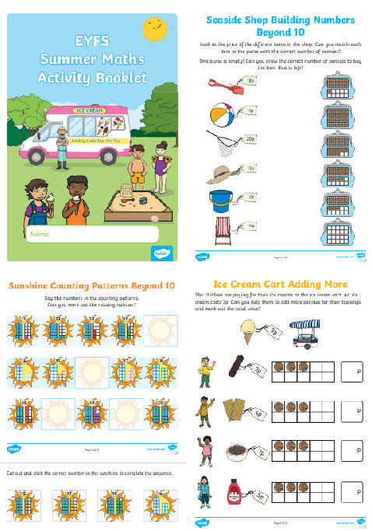

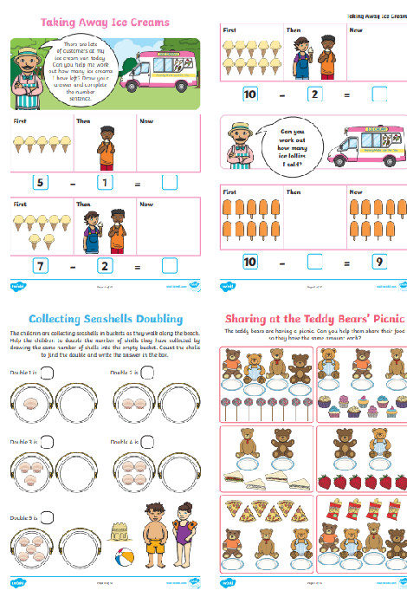

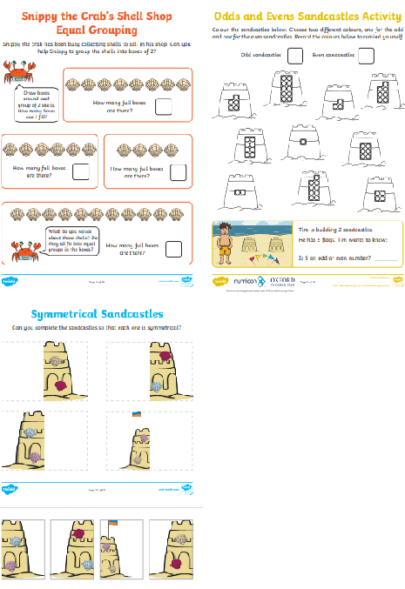
Many thanks
The Reception Team.

