Key questions:
- Can you describe the course of a river using the correct geographical language?
- Can you explain how rivers affect landscapes?
- How are volcanoes formed?
- How are earthquakes caused?
- Where are some of the world’s most famous volcanoes?
Key facts and figures
How are volcanoes formed? | - Magma rises through cracks or weaknesses in the Earth's crust.  - Pressure builds up inside the Earth.  - When this pressure is released, e.g. as a result of plate movement, magma rises to the surface causing a volcanic eruption.  - The lava from the eruption cools to form a new crust.  - Over time, after several eruptions, the rock builds up and a volcano forms. | 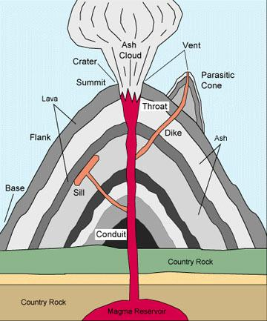
What causes an earthquake? | An earthquake is the shaking and vibration of the Earth's crust due to movement of the Earth's plates (plate tectonics). Earthquakes can happen along any type of plate boundary. Earthquakes occur when tension is released from inside the crust. Plates do not always move smoothly alongside each other and sometimes get stuck. When this happens, pressure builds up. When this pressure is eventually released, an earthquake happens. | 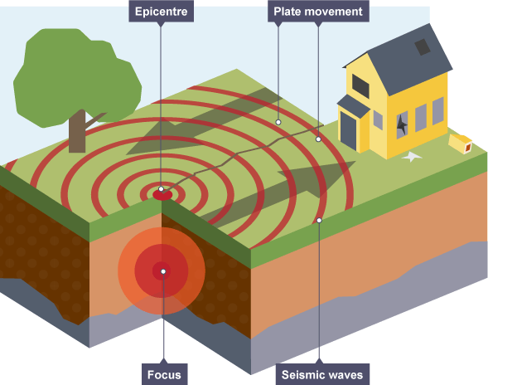
What are the features of a river? | 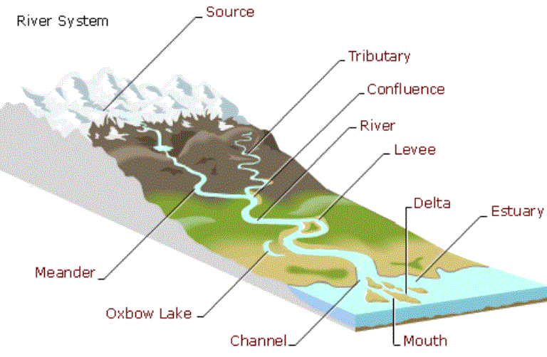

Did you know…?
- The shortest river in the world is the Ombla: it is only 30m long!
- Half of the top ten rivers by length are in Asia.
- If all of the water in the world could fit into a gallon container, only one teaspoon would be fresh-water.
- In terms of volume of water that moves through a river, the Amazon is actually the biggest. (Bigger than the next 5 combined!)
- The word volcano originally comes from the name of the Roman god of fire, Vulcan.
- Volcanic eruptions can send ash high into the air, over 30km (17 miles) above the Earth’s surface.
- The most powerful earthquake ever recorded was in Valdivia, Chile. Occurring in 1960, it had a magnitude of 9.5
Key vocabulary
- Sedimentary  - Igneous  - Metamorphic  - Source  - Meander  - Tributary  - Reservoir  - Well | - Volcano  - Waterfall  - Water Cycle  - Earthquake  - Borehole  - Mudflats  - Dunes  - Landslide | - Plate tectonics  - Epicentre  - Dormant  - Erosion  - Settlement  - Undercut  - Rockfall  - Undercut

