Key vocabulary:
- multiplication  - multiples  - multiply  - times  - division  - divide  - inverse operations  - commutative law  - distributive law  - integers  - factors | - measure  - millimetres, centimetres, metres, kilometres  - convert between units of measure  - length  - perimeter  - area  - rectilinear
Curriculum Objectives
Year 3  Number – Multiplication and Division  Write and calculate mathematical statements for multiplication and division using the multiplication tables they know, including for two-digit numbers times one-digit numbers, using mental and progressing to formal written methods.  Solve problems, including missing number problems, involving multiplication and division, including positive integer scaling problems and correspondence problems in which n objects are connected to m objectives.  Measurement – Length and Perimeter  Measure, compare, add and subtract: lengths (m/cm/mm).  Measure the perimeter of simple 2D shapes.  Continue to measure using the appropriate tools and units, progressing to using a wider range of measures, including comparing and using mixed and simple equivalents of mixed units. | Year 4  Number – Multiplication and Division  Multiply two digit and three digit numbers by a one digit number using formal written layout.  Solve problems involving multiplying and adding, including using the distributive law to multiply two digit numbers by one digit, integer scaling problems and harder correspondence problems such as n objects are connected to m objects.  Recognise and use factor pairs and commutativity in mental calculations.  Measurement – Length, Perimeter and Area  Measure and calculate the perimeter of a rectilinear figure (including squares) in centimetres and metres  Convert between different units of measure e.g. kilometre to metre.  Find the area of rectilinear shapes by counting squares.
Examples
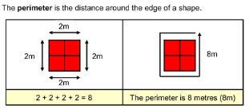

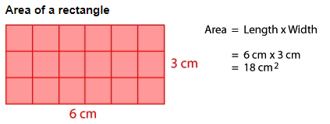

For more information, please see the Calculation Policy on the website.

